Test Case: tc003_SPX_Dev5_Crear_Requisicion_Spot_Tipo_Cobro_CC_Urgent
Step 1 - Enter username and password and click to button Enter : Credentials Entered
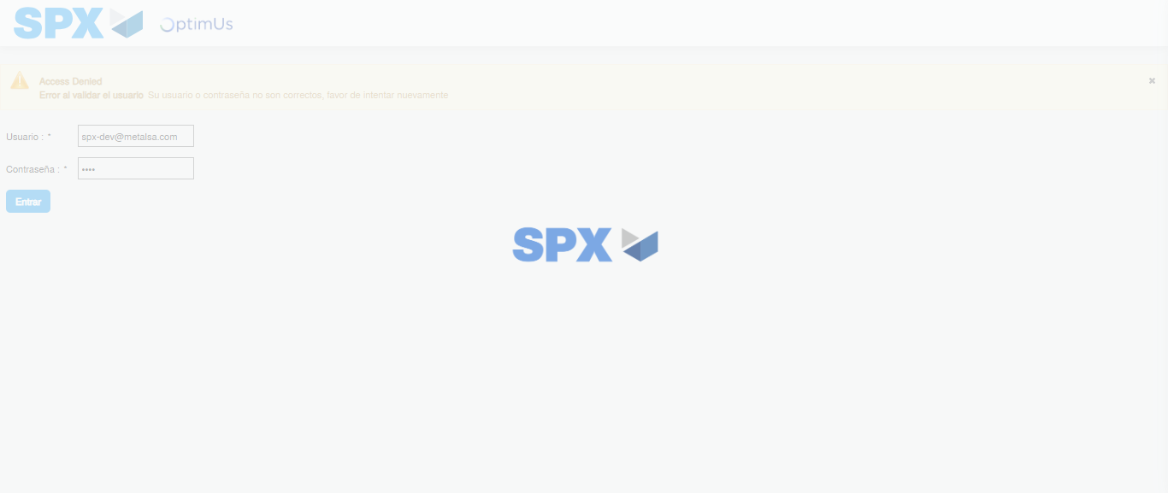Image file-name: QC_Testing-tc003_SPX_Dev5_Crear_Requisicion_Spot_Tipo_Cobro_CC_Urgent-1782315444149

Step 2 - Select to UEN and Access to Spot Buy Requisitions : UEN Correctly selected and Correct access
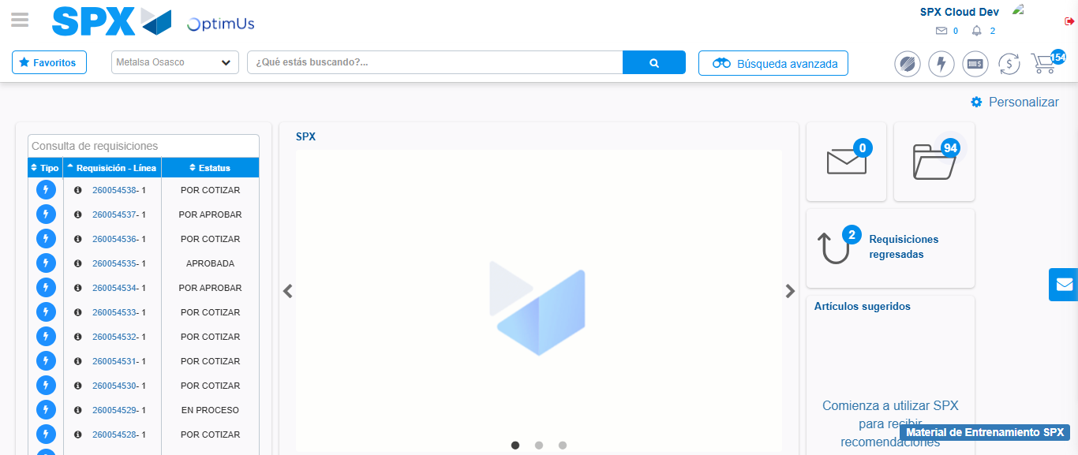Image file-name: QC_Testing-tc003_SPX_Dev5_Crear_Requisicion_Spot_Tipo_Cobro_CC_Urgent-1782315506123

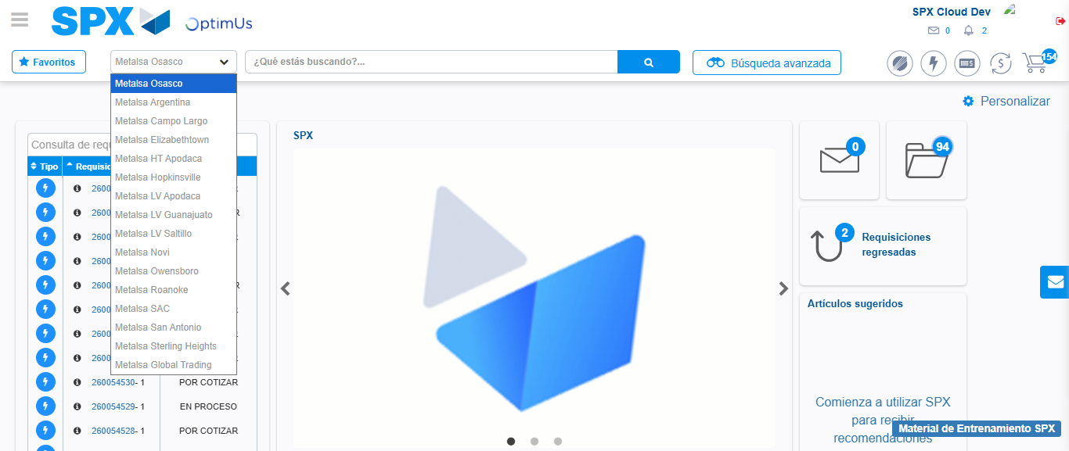Image file-name: QC_Testing-tc003_SPX_Dev5_Crear_Requisicion_Spot_Tipo_Cobro_CC_Urgent-1782315508837

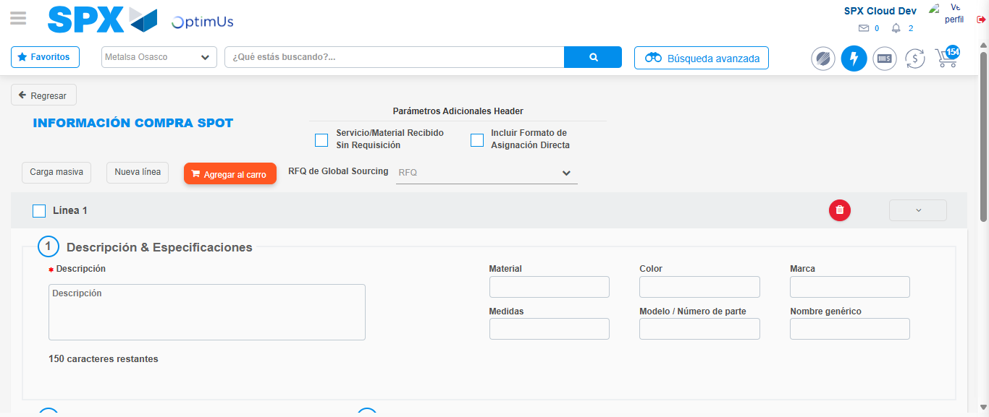Image file-name: QC_Testing-tc003_SPX_Dev5_Crear_Requisicion_Spot_Tipo_Cobro_CC_Urgent-1782315520950

Step 3 - Data Capture Spot Buy Requisition: Data captured correctly
Image file-name: QC_Testing-tc003_SPX_Dev5_Crear_Requisicion_Spot_Tipo_Cobro_CC_Urgent-1782315521258

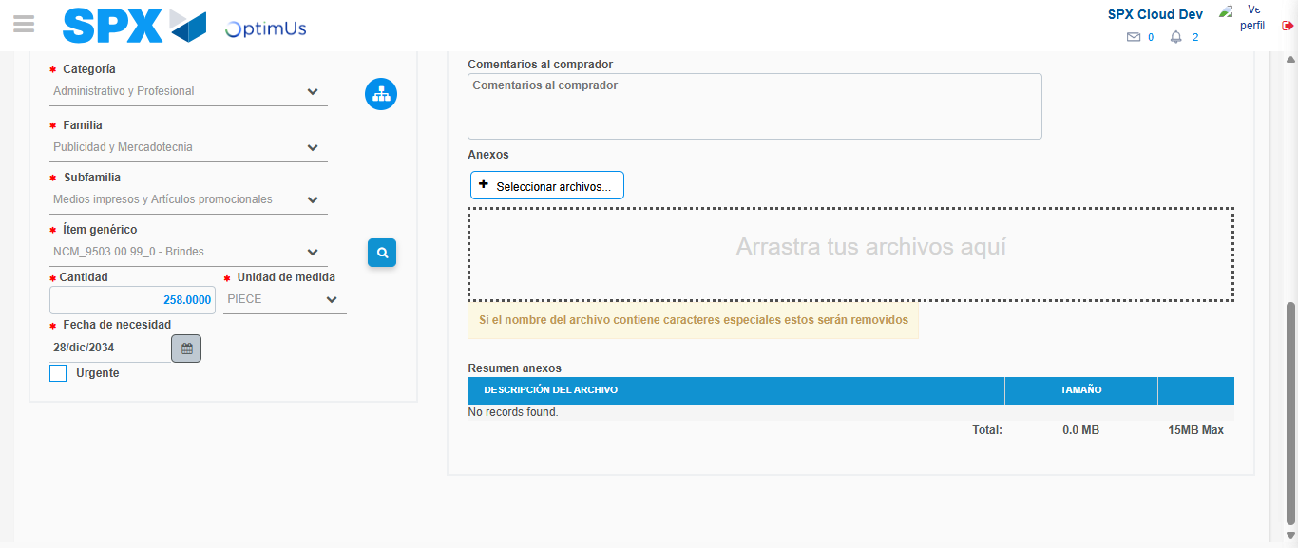Image file-name: QC_Testing-tc003_SPX_Dev5_Crear_Requisicion_Spot_Tipo_Cobro_CC_Urgent-1782315534573

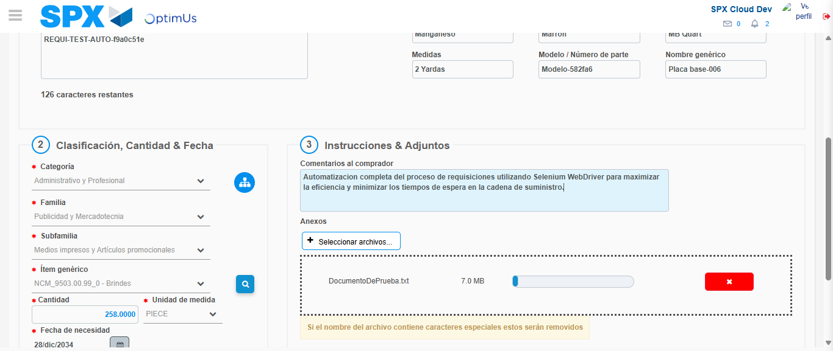Image file-name: QC_Testing-tc003_SPX_Dev5_Crear_Requisicion_Spot_Tipo_Cobro_CC_Urgent-1782315535456

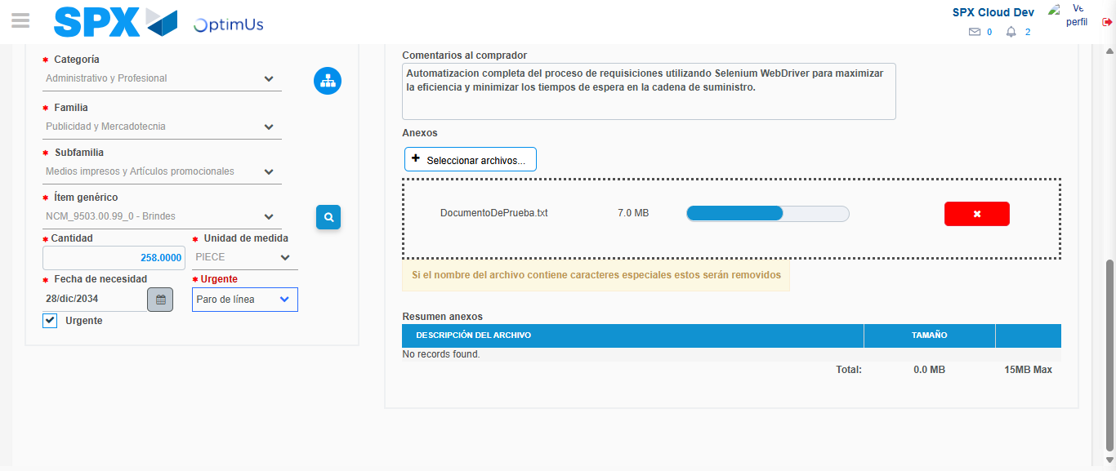Image file-name: QC_Testing-tc003_SPX_Dev5_Crear_Requisicion_Spot_Tipo_Cobro_CC_Urgent-1782315539228

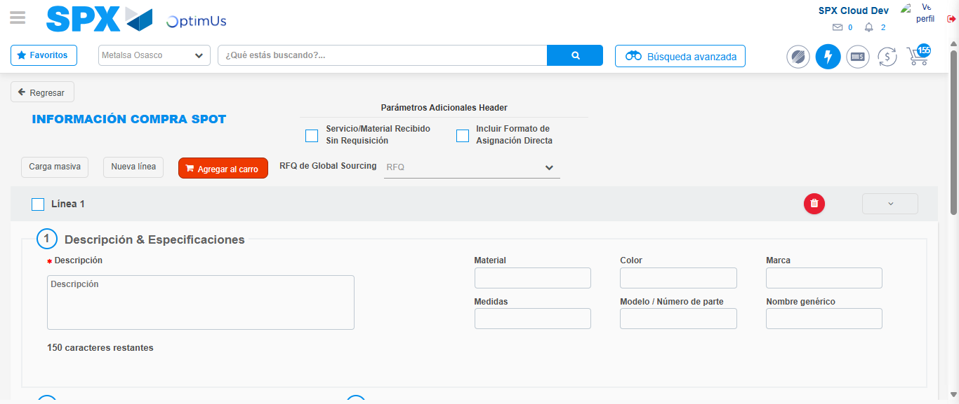Image file-name: QC_Testing-tc003_SPX_Dev5_Crear_Requisicion_Spot_Tipo_Cobro_CC_Urgent-1782315546228

Step 7 - Return to Main Page SPX : Return to Main Page SPX
Image file-name: QC_Testing-tc003_SPX_Dev5_Crear_Requisicion_Spot_Tipo_Cobro_CC_Urgent-1782315506123

Image file-name: QC_Testing-tc003_SPX_Dev5_Crear_Requisicion_Spot_Tipo_Cobro_CC_Urgent-1782315508837

Image file-name: QC_Testing-tc003_SPX_Dev5_Crear_Requisicion_Spot_Tipo_Cobro_CC_Urgent-1782315520950

Image file-name: QC_Testing-tc003_SPX_Dev5_Crear_Requisicion_Spot_Tipo_Cobro_CC_Urgent-1782315548473

Image file-name: QC_Testing-tc003_SPX_Dev5_Crear_Requisicion_Spot_Tipo_Cobro_CC_Urgent-1782315548679

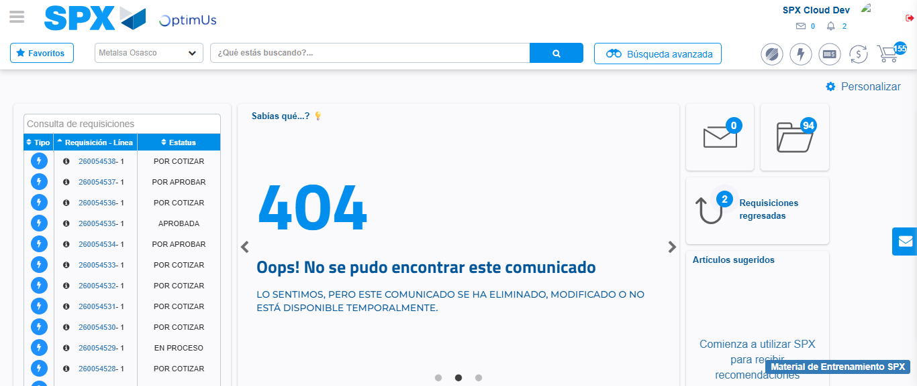Image file-name: QC_Testing-tc003_SPX_Dev5_Crear_Requisicion_Spot_Tipo_Cobro_CC_Urgent-1782315569811

Step 8 - Log Out : Log Out SPX
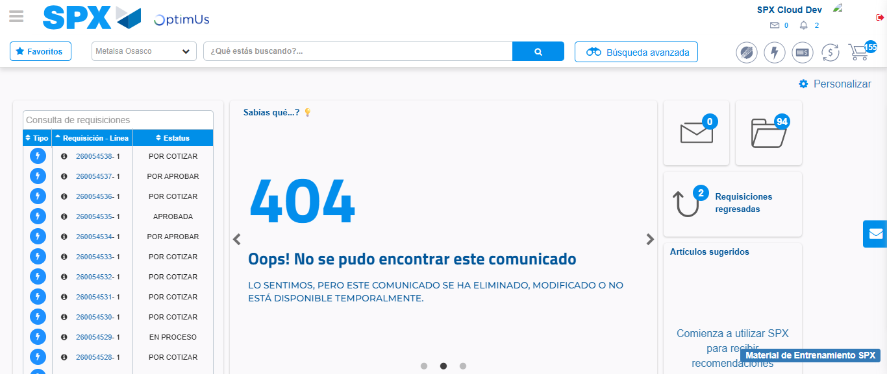Image file-name: QC_Testing-tc003_SPX_Dev5_Crear_Requisicion_Spot_Tipo_Cobro_CC_Urgent-1782315570076

